**GUVI**

**FULL STACK DEVELOPMENT – MERN**

**B51WD – ENGLISH**

**DAY 3 TASK – 20.08.2023**

**- BALAJI S**

**Q1. How do you compare two JSON have the same properties without the same order?**

**Solution:**

* Sort the JSON objects and store it in the same JSON variable
* Use Stringify method and store it in a separate variable
* Now return true or false by comparing both the variables.

let obj1 = {name: "Person 1", age: 5};

let obj2 = {age: 5, name: "Person 1"};

obj1 = Object.keys(obj1).sort();

obj2 = Object.keys(obj2).sort();

var sortedObj1 = JSON.stringify(obj1);

var sortedObj2 = JSON.stringify(obj2);

var result = sortedObj1 === sortedObj2;

console.log(result);

**Result:** The above program will return **True**.

**Q2.Using the rest countries API and displaying the countries flags in the console.**

var request = new XMLHttpRequest();

request.open('GET', 'https://restcountries.com/v3.1/all');

request.send();

request.onload = function() {

      var data = JSON.parse(request.responseText);

      for (var countryKey in data) {

            var country = data[countryKey];

             var flags = country.flags;

             console.log(flags);

            }

        };

**Output:**

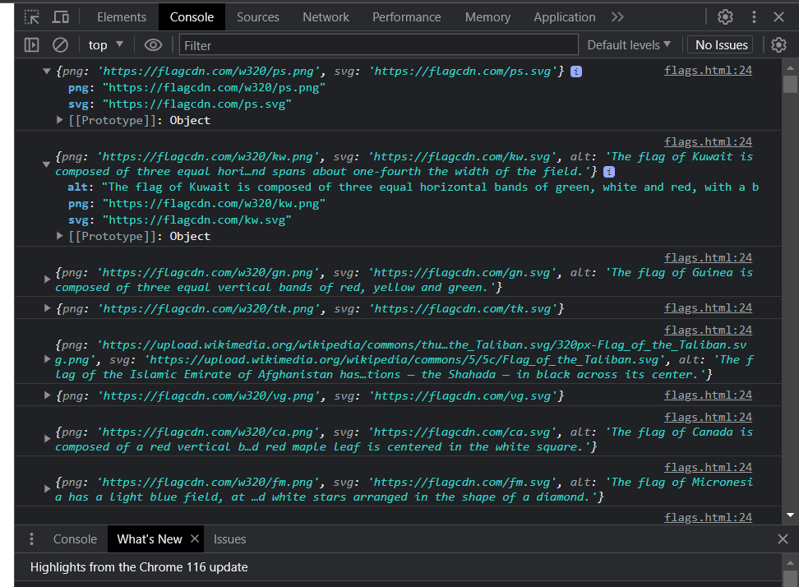

**Q3.Use the same rest countries API and print all countries name, region, sub-region and population.**

var request2 = new XMLHttpRequest();

request2.open('GET','https://restcountries.com/v3.1/all');

request2.send();

request2.onload = function(){

            var data = JSON.parse(request2.response);

            for(var countryKey in data){

                var country = data[countryKey];

                var name = country.name.common;

                var region = country.region;

                var subregion = country.subregion;

                var population = country.population;

                console.log(name);

                console.log(region);

                console.log(subregion);

                console.log(population);

      }

}

**Output:**

